Business Data Analysis Assignment 01

Name: Muhammad Anas Nasir

Reg. No: FA23-BBD-086

Class: BDA-4C

Importing Librairies
import pandas as pd
import numpy as np
import statistics as st
chronic_diseases = pd.read_csv('chronic_disease.csv')
chronic_diseases.head(15)
Patient_Number BP_Abnormality Female Level_of_Hemoglobin Age BMI \
0 1 1 1 11.28 34 23
1 2 0 1 9.75 54 33
2 3 1 0 10.79 70 49
3 4 0 0 11.00 71 50
4 5 1 0 14.17 52 19
5 6 0 0 11.64 23 48
6 7 1 1 11.69 43 41
7 8 0 0 12.70 48 20
8 9 0 0 10.88 72 44
9 10 1 0 14.56 40 44
10 11 1 1 8.58 70 28
11 12 1 0 12.77 35 17
12 13 1 0 16.40 31 50
13 14 0 0 16.42 75 40
14 15 0 0 11.97 18 32
Smoking Steps_Walk_Week Chronic_kidney_disease \
0 0 45961 1
1 0 26106 0
2 0 9995 1
3 0 10635 1
4 0 15619 0
5 1 27042 0
6 0 38369 1
7 0 29781 0
8 0 814 0
9 0 1278 0
10 0 48527 1
11 0 22500 1
12 1 25639 0
13 1 11750 0
14 0 14562 1
Adrenal_and_thyroid_disorders
0 1
1 0
2 0
3 0
4 0
5 0
6 1
7 0
8 0
9 0
10 1
11 0
12 1
13 1
14 1
From the first 15 rows of the dataset it is clear that:
- Some patients have both chronic_disease and adrenal/thyroid disorders, while others have none.
- Most pateints in the dataset are non-smokers.
- The number of steps walked per week also vary greatly.
- Ages, BMI, and hemoglobin levels vary widely.
chronic_diseases.info()
<class 'pandas.core.frame.DataFrame'>
RangeIndex: 2000 entries, 0 to 1999
Data columns (total 10 columns):
# Column Non-Null Count Dtype
--- ------ -------------- -----
0 Patient_Number 2000 non-null int64
1 BP_Abnormality 2000 non-null int64
2 Female 2000 non-null int64
3 Level_of_Hemoglobin 2000 non-null float64
4 Age 2000 non-null int64
5 BMI 2000 non-null int64
6 Smoking 2000 non-null int64
7 Steps_Walk_Week 2000 non-null int64
8 Chronic_kidney_disease 2000 non-null int64
9 Adrenal_and_thyroid_disorders 2000 non-null int64
dtypes: float64(1), int64(9)
memory usage: 156.4 KB
The dataset contanis information about patients and various health-related factors that may be associated with chronic diseases.
Each row represents a patient, and the columns provide details such as:
- Patient_Number: Unique identifier for each patient.
- BP_Abnormality: Indicator of normal blood pressure (likely 0 = No, 1 = Yes).
- Female = Gender indicator (1 = Female, 0 = Male).
- Level_of_Hemoglobin: Hemoglobin level in blood.
- Age: Age of the Patient.
- BMI: Body Mass Index.
- Smoking: Smoking Status (0 = Non-smoker, 1 = Smoker)
- Steps_Walk_Week: Number of steps walked in a week.
- Chronic_kidney_disease: Presence of chronic kidney disease (0 = No, 1 = Yes).
- Adrenal_and_thyroid_disorders: Presence of adrenal and thyroid disorders (0 = No, 1 = Yes)
chronic_diseases.tail(15)
Patient_Number BP_Abnormality Female Level_of_Hemoglobin Age BMI \
1985 1986 0 0 10.44 38 31
1986 1987 1 1 13.63 49 36
1987 1988 1 0 11.79 19 44
1988 1989 1 0 17.17 20 48
1989 1990 1 0 10.84 20 15
1990 1991 1 0 11.21 63 25
1991 1992 1 0 15.53 22 24
1992 1993 1 1 9.38 60 39
1993 1994 0 1 9.69 73 42
1994 1995 0 1 11.07 58 31
1995 1996 1 1 10.14 69 26
1996 1997 1 1 11.77 24 45
1997 1998 1 0 16.91 18 42
1998 1999 0 1 11.15 46 45
1999 2000 1 0 11.36 41 45
Smoking Steps_Walk_Week Chronic_kidney_disease \
1985 0 6109 0
1986 0 49302 1
1987 0 35633 0
1988 0 33663 1
1989 0 1162 1
1990 1 32903 0
1991 0 48325 1
1992 1 46591 1
1993 1 43344 0
1994 0 38603 0
1995 1 26118 1
1996 1 2572 1
1997 0 14933 1
1998 1 18157 0
1999 0 20729 1
Adrenal_and_thyroid_disorders
1985 0
1986 1
1987 1
1988 0
1989 0
1990 0
1991 1
1992 1
1993 1
1994 0
1995 0
1996 1
1997 1
1998 1
1999 0
The last 15 rows also display the same detail. They also indicate that there are both males and females in this dataset.
chronic_diseases.isnull().sum()
Patient_Number 0
BP_Abnormality 0
Female 0
Level_of_Hemoglobin 0
Age 0
BMI 0
Smoking 0
Steps_Walk_Week 0
Chronic_kidney_disease 0
Adrenal_and_thyroid_disorders 0
dtype: int64
The above command is used to detect if there are any missing values in the dataset. But as we can see, by running the command, there is no missing value in the dataset.
chronic_diseases.describe()
Patient_Number BP_Abnormality Female Level_of_Hemoglobin \
count 2000.000000 2000.000000 2000.000000 2000.000000
mean 1000.500000 0.493500 0.496000 11.710035
std 577.494589 0.500083 0.500109 2.186701
min 1.000000 0.000000 0.000000 8.100000
25% 500.750000 0.000000 0.000000 10.147500
50% 1000.500000 0.000000 0.000000 11.330000
75% 1500.250000 1.000000 1.000000 12.945000
max 2000.000000 1.000000 1.000000 17.560000
Age BMI Smoking Steps_Walk_Week \
count 2000.000000 2000.000000 2000.000000 2000.000000
mean 46.558500 30.081500 0.509500 25254.424500
std 17.107832 11.761208 0.500035 14015.439623
min 18.000000 10.000000 0.000000 628.000000
25% 32.000000 20.000000 0.000000 13605.750000
50% 46.000000 30.000000 1.000000 25353.000000
75% 62.000000 40.000000 1.000000 37382.250000
max 75.000000 50.000000 1.000000 49980.000000
Chronic_kidney_disease Adrenal_and_thyroid_disorders
count 2000.0000 2000.000000
mean 0.5050 0.443500
std 0.5001 0.496922
min 0.0000 0.000000
25% 0.0000 0.000000
50% 1.0000 0.000000
75% 1.0000 1.000000
max 1.0000 1.000000
The descriptive statistics is used to summarize and organize data to describe its main features. It uses numerical computations to present a clear picture of a dataset.
It is used to display key statistics like count (Number of entries in the dataset), mean (The average of all values in the dataset), standard deviation (the distance of a value from the mean), minimum (the lowest value in the dataset), percentiles (1st Quartile (25th), the median (middle value), and the 3rd quartile(75th)), and the maximum value (the highest value in the dataset).
chronic_diseases.shape
(2000, 10)
The chronic_diseases.shape is used to give you the dimensions (rows and columns) of your dataset. From the output we can see that in the dataset, there are 2000 rows (patients (0bservations)) and 10 columns (variables)
chronic_diseases.describe().T
count mean std min \
Patient_Number 2000.0 1000.500000 577.494589 1.0
BP_Abnormality 2000.0 0.493500 0.500083 0.0
Female 2000.0 0.496000 0.500109 0.0
Level_of_Hemoglobin 2000.0 11.710035 2.186701 8.1
Age 2000.0 46.558500 17.107832 18.0
BMI 2000.0 30.081500 11.761208 10.0
Smoking 2000.0 0.509500 0.500035 0.0
Steps_Walk_Week 2000.0 25254.424500 14015.439623 628.0
Chronic_kidney_disease 2000.0 0.505000 0.500100 0.0
Adrenal_and_thyroid_disorders 2000.0 0.443500 0.496922 0.0
25% 50% 75% max
Patient_Number 500.7500 1000.50 1500.250 2000.00
BP_Abnormality 0.0000 0.00 1.000 1.00
Female 0.0000 0.00 1.000 1.00
Level_of_Hemoglobin 10.1475 11.33 12.945 17.56
Age 32.0000 46.00 62.000 75.00
BMI 20.0000 30.00 40.000 50.00
Smoking 0.0000 1.00 1.000 1.00
Steps_Walk_Week 13605.7500 25353.00 37382.250 49980.00
Chronic_kidney_disease 0.0000 1.00 1.000 1.00
Adrenal_and_thyroid_disorders 0.0000 0.00 1.000 1.00
A count value of 2000 Patient_Number in the dataset tell us that there are 2000 patients in it. About half are female. The average age is about 46.6 years, with a range from 18 to 75. The average BMI is about 30.1, ranging from 10 to 50. About half have abmormal blood pressure, chronic kideny disease, or are smokers.
The average hemoglobin level is 11.7. Steps walked per week vary widely. Adrenal and thyroid disorders are present in about 44% of patients.
Percentile: Percentile refers to relative standing of a value in the representative dataset.
If we caompare the percentiles of patients that have their BMI monitored we can interpret in the manner as explained below:
There are 25% of patients that have a BMI value less than 20, 50% of the patients fall in the median value of 30, and 75% of patients have a BMI value less than 40, it can also be interpreted in a way like 25% of patients have a BMI value greater than 40. There is a little variation in the mean and median value, indicating that there are little to no outiers in the dataset. We get an impression that the dataset had already been cleaned, or there were no anomalies that would affect the normality of dataset.
chronic_diseases.columns
Index(['Patient_Number', 'BP_Abnormality', 'Female', 'Level_of_Hemoglobin',
'Age', 'BMI', 'Smoking', 'Steps_Walk_Week', 'Chronic_kidney_disease',
'Adrenal_and_thyroid_disorders'],
dtype='object')
chronic_diseases.Patient_Number
0 1
1 2
2 3
3 4
4 5
...
1995 1996
1996 1997
1997 1998
1998 1999
1999 2000
Name: Patient_Number, Length: 2000, dtype: int64
chronic_diseases.mean()
Patient_Number 1000.500000
BP_Abnormality 0.493500
Female 0.496000
Level_of_Hemoglobin 11.710035
Age 46.558500
BMI 30.081500
Smoking 0.509500
Steps_Walk_Week 25254.424500
Chronic_kidney_disease 0.505000
Adrenal_and_thyroid_disorders 0.443500
dtype: float64
The chronic_diseases.mean() is used to display the mean values of all the variables in the dataset.
print(chronic_diseases.mean(axis = 1, numeric_only=True))
0 4603.428
1 2620.575
2 1012.979
3 1077.200
4 1571.017
...
1995 2822.314
1996 465.477
1997 1701.091
1998 2026.115
1999 2282.836
Length: 2000, dtype: float64
The above command has given us mean statistics for each patient across all numeric columns.
chronic_diseases.groupby('Smoking').mean(['Level_of_Hemoglobin'])
Patient_Number BP_Abnormality Female Level_of_Hemoglobin \
Smoking
0 987.002039 0.487258 0.496432 11.658012
1 1013.494603 0.499509 0.495584 11.760118
Age BMI Steps_Walk_Week Chronic_kidney_disease \
Smoking
0 46.117227 29.974516 25468.265036 0.517839
1 46.983317 30.184495 25048.558391 0.492640
Adrenal_and_thyroid_disorders
Smoking
0 0.434251
1 0.452404
The groupby analysis has grouped patients with smoking status to the mean of all other variables in the dataset.
- Row 0 represent patients that are non-smoker and 1 indicate patients that smoke. More accurately, there are around 987 patients that fall in the category of non-smokers and about 1013 patients are smokers.
- Non-smokers have an average hemoglobin level of 11.66, while non-smokers have a hemoglobin level of 11.76, indicating that there is a slightly higher average hemoglobin level than non-smokers.
- Non-smokers have an average age of 46.12 years, while non-smokers are aged at an average value of 46.98. This statitic indicates that smokers are a little older than non-smokers.
- Smokers slightly have a higher average BMI (30.18) than non-smokers (29.97).
- Non-smokers walk more steps (25,469), than smokers (25,049)
- A slightly higher proprotion of non-smokers have chronic kidney disease (0.52), than smokers (0.50).
- Adrenal and thyroid disorders are slightly more common among smokers (0.45), than non-smokers (0.43)
- The mean value for BP_Normality and Females is close for both smokers and non-smokers, indicating smaller distribution of gender and blood pressure abnormality among smokers and non-smokers.
print(chronic_diseases.median(numeric_only=True))
Patient_Number 1000.50
BP_Abnormality 0.00
Female 0.00
Level_of_Hemoglobin 11.33
Age 46.00
BMI 30.00
Smoking 1.00
Steps_Walk_Week 25353.00
Chronic_kidney_disease 1.00
Adrenal_and_thyroid_disorders 0.00
dtype: float64
The above command has given us insights about the median of each variable numerical column in the dataset.
chronic_diseases.mode(axis = 0, numeric_only = False, dropna = True)
Patient_Number BP_Abnormality Female Level_of_Hemoglobin Age BMI \
0 1 0.0 0.0 12.07 18.0 11.0
1 2 NaN NaN NaN NaN 38.0
2 3 NaN NaN NaN NaN NaN
3 4 NaN NaN NaN NaN NaN
4 5 NaN NaN NaN NaN NaN
... ... ... ... ... ... ...
1995 1996 NaN NaN NaN NaN NaN
1996 1997 NaN NaN NaN NaN NaN
1997 1998 NaN NaN NaN NaN NaN
1998 1999 NaN NaN NaN NaN NaN
1999 2000 NaN NaN NaN NaN NaN
Smoking Steps_Walk_Week Chronic_kidney_disease \
0 1.0 768.0 1.0
1 NaN 1482.0 NaN
2 NaN 2971.0 NaN
3 NaN 4591.0 NaN
4 NaN 5620.0 NaN
... ... ... ...
1995 NaN NaN NaN
1996 NaN NaN NaN
1997 NaN NaN NaN
1998 NaN NaN NaN
1999 NaN NaN NaN
Adrenal_and_thyroid_disorders
0 0.0
1 NaN
2 NaN
3 NaN
4 NaN
... ...
1995 NaN
1996 NaN
1997 NaN
1998 NaN
1999 NaN
[2000 rows x 10 columns]
Mode is the most frequent(ocurring) value in the dataset. It displays values that have repreated more frequently and it is suitable for variables that are categorical in nature.
- For most columns, only first row has values, the rest are NaN (Not a Number), which means that there is only one mode for each column.
- Patient Number is meaningless becuase each patient has been assigned a unique number. A BP_Abnormality of 0 indicates that most of the patients have normal blood pressure.
- A statistic of 0 in female column indicates that most patients are male.
- Level_of_Hemoglobin is 12.07 indicating that most patients have a hemoglobin level of 12.07.
- The most common age of patients is 18.
- The most common BMI is 11.0
- Smoking status is indicating a level of 1, which means that most of the pateints are smokers.
- Most patients have chronic_disease (1)
- Most patients do not have adrenal and thyroid disorders (0.0)
import matplotlib.pyplot as plt
import seaborn as sns
sns.boxplot(x='Smoking', y='BMI', data=chronic_diseases)
plt.title('Box-and-Whisker Plot of BMI by Smoking Status')
plt.xlabel('Smoking (0 = Non-smoker, 1 = Smoker)')
plt.ylabel('BMI')
plt.show()
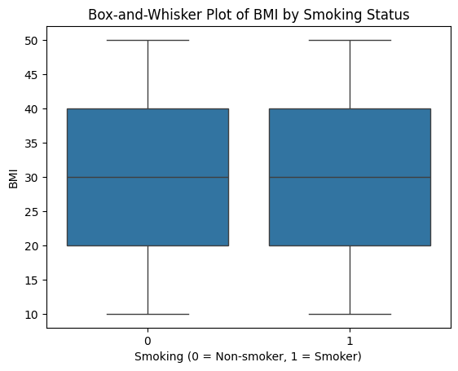
The box-and-whisker plot compares the distribution of BMI between smokers and non-smokers:
Median: Both groups have similar median BMI, around 30.
IQR: The middle 50% of BMI values for both groups are spread similarly, showing similar variability.
Whiskers: The minimum and maximum BMI values (excluding outliers) are almost the same for both groups, ranging from about 10 to 50.
Outliers: There are no outliers in either group, meaning all BMI values fall within the expected range.
plt.figure(figsize=(10,6))
plt.boxplot(chronic_diseases['BMI'])
plt.title('Box and Whisker Plot')
plt.xlabel('BMI')
plt.show()
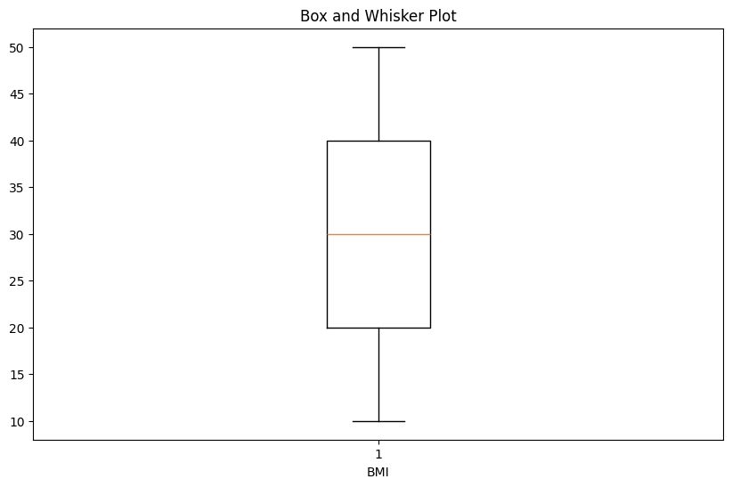
The Box-and-Whisker Plot shows distribution of BMI for all pateints in the dataset.
Median: The median BMI is around 30, meaning half of the patients have a BMI below 30 and half above.
IQR: The box represents the middle 50% of BMI values, ranging roughly from 20 to 40. This shows that patients have a BMI in this range.
Whiskers: The lines extending from the box show the minimum and maximum BMI values (excluding outliers), which are about 10 to 50.
No Outliers: The are no extreme values in the dataset, indicating all BMI values fall within the expected range.
plt.hist(chronic_diseases['BMI'])
plt.show()
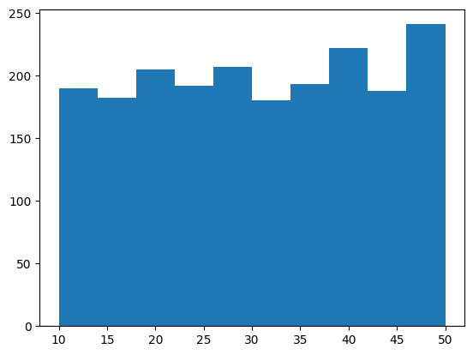
The Histogram is used to interpret on the data nomramilty of any column of your dataset. Based on the generated output the data is not normally distributed, if it were to be distributed normally the graph would have displayed a bell-shaped curved.
There is no left or right skewness indicating that the line is roughly in the center of the box, supporting lack of skewness. The BMI in the dataset shows little to no skewness and is close to uniform or symmetric distribution.

